**FoCA Fundamentals of Computer Architecture**

**Assignment 2 Brief**

**x86 Assembly Programming**

**The Encryption/Decryption Program**

**Please read this brief thoroughly so you know what's involved, and follow the instructions therein. If you need clarification on any point just ask.**

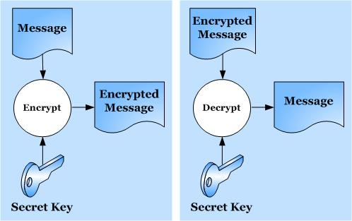

**You write this! ☹**

**You're given this ☺**

**Not so !**

**Tutors: Adrian Oram / Mark Marshall / Mike Meredith**

**Cohort: 2017-2018**

**FoCA - Assignment 2 Brief - The Encryption/Decryption Program**

**Overview**

This assignment is designed to test your understanding of x86 assembly and how it can be used in a C++ program. The tasks involved are based on an **encryption/decryption** program.

You are provided with a program written in C++ and x86 assembly that you will work with. Running this program and studying the code is recommended so that you become familiar with what it does - it allows the user to type in a number of alphanumeric (ASCII) characters and these are then ‘encrypted’, or converted, to another value. Both the original and encrypted character strings are echoed to the screen (see screen shot, overleaf), along with their hexadecimal values.

The program provided currently uses an extremely simple form of encryption – it simply moves the character up one place in the ASCII table (by adding 1 to the character code), so decrypting it would be a simple matter of moving it back down one position - not a very strong encryption method, I’m sure you’ll agree!

However, you will each be allocated an encryption method - written in x86 assembly - that you will paste into the original program to replace the existing ‘encrypt’ subroutine. There are currently 22 variations of these and each uses a more convoluted form of encryption than just adding 1. These encryption routines also employ a unique **encryption key** that will be allocated to each of you. Note that none of the encryption methods are 'real' - you won't find them being used by the security industry - they're invented purely for the purposes of this assignment.

Eventually you will write a **decryption** routine using **x86 assembly** to reverse the encryption process, but there are other tasks too, and these are phased as three milestones (described later).

**Preliminary Requirements**

This assignment document and other required materials are all available on Blackboard (Bb), under the ‘Assessment’ tab.

You may also download a copy of the **Encryption Program MARKS SHEET** document, although printed copies of this will be given out. You should fill this in with your name and other details and print a copy if you choose to use the downloaded form. This will be used to record your marks as you progress through the assignment, and will be returned to you after each milestone for feedback/forward. **PLEASE KEEP IT CAREFULLY throughout the assignment.**

You may also need a copy of the **ASCII table** for reference, if you’ve lost yours. Access to your FoCA lecture notes and tutorials will also be useful.

Last, but not least, you need your brain!

**Please follow the next few steps carefully and fully.**

**a) Find your encryption key and allocated encryption routine number**

Your allocated key and encryption method are listed in a separate document on Bb:

**FoCA Assignment 2 2018 Encryption keys and code allocations.docx**

Open this file and find your name in the list. Make a note below of your **encryption key** (a single character, its case - upper or lower - is important) and which **encryption routine** (1-22) you should be using:

**Key Encryption routine number**

**b) Familiarise yourself with the supplied program & code**

Download the original C++/x86 assembly project file from the assignments area, and unzip it:

**FoCA Assignment 2 Encryption.zip**

Open the **.sln** file in Visual Studio (VS) - this project is the starting point for the assignment. Take some time to inspect the C++ and x86 assembly code and how it's structured (it's not complicated).

**Immediately**, edit the first few lines as follows (see box, below):

* Overwrite "**Adrian Oram**" with your name in the **StudentName** field. This ensures the code is identifiable as yours (and is used in the output file, see below).
* Overwrite the **Ekey = 'x'** with your allocated character replacing the **x**. This avoids having to enter it every time you run the program.

// Filename: "FoCA 2018 Encryption Original with ASM.cpp"

// Last revised Feb 2018 by A.Oram

char EKey = 'x'; // Replace x with your Encryption key.

#define StudentName "Adrian Oram"

#define MAXCHARS 6 // feel free to alter this, but 6 is the minimum

Note that the constant value governing the number of characters that can be entered by the user:

#define MAXCHARS 6

can be changed as you wish but 6 characters is the minimum number your final submitted version of the program should be run with.

Now build and run the program, entering a short text string when prompted.

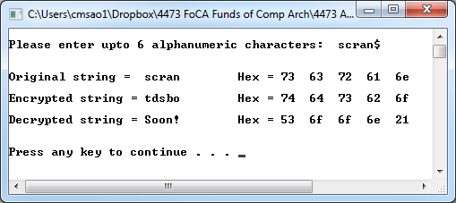In the screen shot opposite **‘scran’** is the original character string entered; '**$**' can be used as a terminating character if less than 6 chars are to be typed (any seventh or subsequent character is currently ignored by the program anyway). Press **Enter** after typing 6 or more characters.

The resulting **Encrypted string** version of ‘scran’ is ‘**tdsbo**’ - each character is simply moved one position up the alphabet in this simple version. ‘HAL’ would become ‘IBM’.[1].

The **Decrypted string** shows “**Soon!**” indicating that you have some work to do - eventually the decrypted string will (should!) show the original string again.

It may eventually be fruitful to 'hardwire' a test string as the original data, to avoid entering it each time. To do this simply add your required characters to the declarations as shown below (e.g. using "Scran" as the test string):

**Before After**

char OChars[MAXCHARS], char OChars[MAXCHARS] = **"Scran"**,

EChars[MAXCHARS], EChars[MAXCHARS],

DChars[MAXCHARS] = "Soon!"; DChars[MAXCHARS] = "Soon!";

**Note**: strictly speaking you should initialise this char array with individual characters, like this:

char OChars[MAXCHARS] = **{'s','c','r','a','n',' '}**

but using the double quotes, "string" version is OK. You will need to use one less character than MAXCHARS however, because of the way strings are stored.

Then comment out the lines that request the original string input (in 'main') and initialise **char_count** with the length of your test string (the number of characters, 5 here):

int char_count (**5**);

**//**cout << "\nPlease enter upto " << MAXCHARS << " alphanumeric characters: ";

**//**get_original_chars (char_count);

The hex ASCII codes of all of the original, encrypted, and decrypted characters are also displayed on the screen, as shown. Note that if the hex codes 0x**0A** or 0x**0D** occur in the encrypted string then the display may appear strangely formatted. This isn't a bug – check these two values in your ASCII table to understand what is happening.

For convenience, the console output is also appended to a text file, called **EncryptDump.txt** which can be viewed in VS (see below) - find it under the **Resources** tab in the project. You can edit and delete this file easily in VS if needbe, or use Notepad or similar on the file in the project directory. In VS use **Ctrl-A** then **delete** to clear it when necessary.

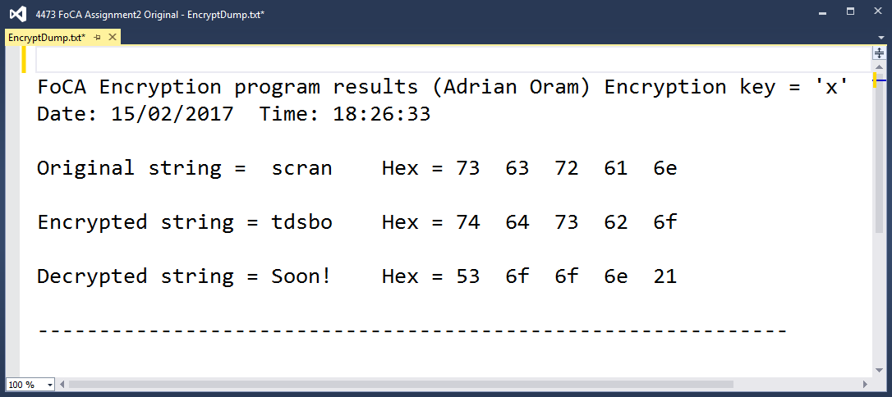

Each time you run the program you will be prompted about whether or not you want to update (actually, *append*, or add to) this file with the results - usually 'Yes' is the answer (press Enter) but you can avoid it too with 'No'.

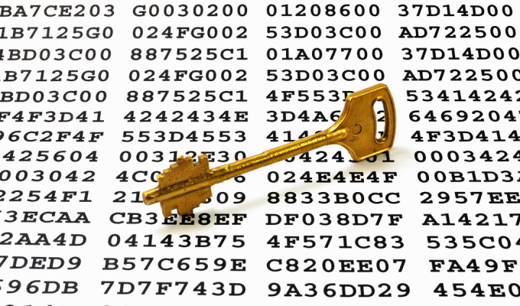

**c) Install and run your allocated encryption code**

Open the document on Bb:

**FoCA Assignment 2 2018 Encryption routines.txt**

Locate your encryption code label, e.g. ‘encrypt_5:’ and copy to the clipboard everything down to the next **ret** instruction (they are around 10 – 15 lines of x86 assembly), e.g.

;--------------------------

**encrypt_5:** push eax

mov al,byte ptr [eax]

push ecx

and eax,0x7C

ror eax,1

ror eax,1

inc eax

mov edx,eax

pop ecx

pop eax

mov byte ptr [eax],dl

xor edx,ecx

mov eax,edx

rol al,1

ret

Replace the original code version of **encrypt_nn**, shown below, in your program by pasting *your* encrypt routine over it:

**encrypt_nn:**

mov eax,ecx

inc eax

ret

Ensure you also change the **call encrypt_nn** instruction to match the name of yours, i.e. in this case:

**call encrypt_5**

Re-build this version and ensure it works. The output will now show a very different set of encrypted characters. Note that these characters will frequently be non-ASCII, such as **¥æë☺** – the final encrypted character codes will often fall outside of the ‘normal’ range of printable ASCII characters which are between 2016 and 7E16. (see ASCII table), and thus may look strange - that's normal.

You should record the hex values generated for your chosen encrypt test string - you can then easily check that they remain constant as you develop your code (you may accidentally corrupt the encryption routine code whilst doing the assignment).

**Some points to note about the encryption routines**

* The **MOVSX** instruction is used to move byte-sized data (i.e. 8-bit ASCII characters) into dword (double-word) – sized registers, such as EAX (which are 32 bits wide). 'SX' means '**S**ign e**X**tended' and means that the sign bit (the left-most bit of the byte value) is duplicated (‘extended’) throughout the upper 24 bits of the 32 bit register whilst the byte data is copied into the least significant byte. In practice this often means that zeroes are used to fill up the unused parts of the register, e.g.:

**00000000 00000000 00000000 00110001** EAX register

**00110001** byte-sized ‘char’ data

Although the assembler provides a lot of flexibility in moving different sized operands into one another, this is one example of an operand size mismatch, hence a special instruction has to be used. For most purposes a simple MOV instruction works.

The **MOVZX** (zero extend) instruction is similar – except **Z**eroes are used instead of the Sign bit. Note that byte data can be *signed* or *unsigned*…chars are *unsigned*.

* An alternative to this would be to use the register names **AL** and **CL** as pseudonyms for the least significant byte of the **EAX** and **ECX** registers respectively for moves of byte-sized data (see register naming diagram, below) E.g. instead of:

movsx ecx,s_char

movzx eax,EKey

you could use these:

mov cl,s_char

mov al,EKey

This does not however, put zeroes in the rest of the register, therefore if it so happens that the upper part of **EAX**, for example, has some old data in it, then you will probably get unexpected side-effects if some arithmetic is performed on that register! To avoid this zeroise the register before the move with an **XOR** operation, like this:

xor eax,eax // clear EAX register to zero

mov al,EKey // copy encryption key into the low byte of EAX

*(Programming in assembly is full of potential pitfalls like this – that’s why it’s a real programming skill!)*

See the guide on Bb to x86 assembly:

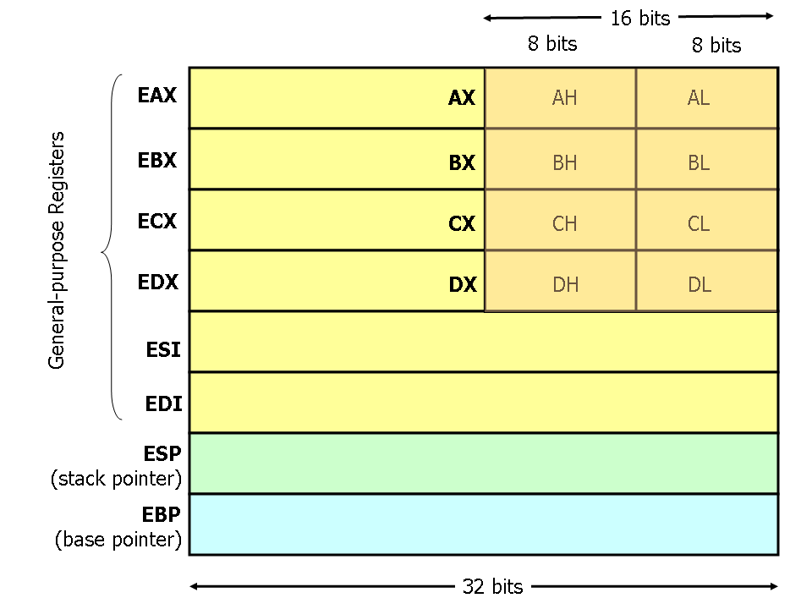 **FoCA x86 Assembly Guide.doc**

for the relationship between the 8, 16 and 32 bit register names, e.g.

**Note**: the encryption routines often employ the 8 bit register names for convenience, e.g. **AL**.

* The *parameters* to the assembly subroutine (inwards: the **encryption key pointer** and the **character to be encrypted**; outwards: the e**ncrypted version of the character**) are passed by moving them into registers **EAX** and **ECX**, respectively. One of your tasks will be to change this so that the standard C++ procedure calling mechanism is used instead, either **CDECL** or **StdCall**.
* Notice the use of **return** to return from the encrypt_chars routine explicitly. Omitting this would allow execution to ‘fall through’ from the C++ code into the encrypt subroutine which would thus be erroneously executed one more time (with probably serious side effects!)

Remember that the full **Intel x86 reference manual** is on Bb. Refer to it when you need details of an instruction.

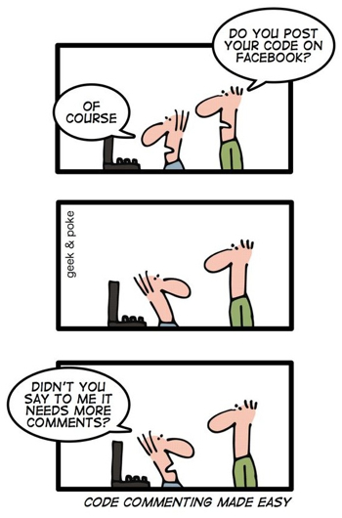**Milestones to be met (and what you need to do…)**



1

**Milestone 1a: Understand the encryption code (up to 10 marks)**

Study the listing of your encryption routine and understand how it is called and encrypts a single character. Each subroutine does this differently; however, all are artificial in that they are not bona fide encryption methods, but that employ simple mathematical manipulations involving your encryption key in a fairly superficial way. You will not find them being used in a real application! They are also deliberately not written well and all could be improved (see Milestone 3)! Generally speaking, each routine alters your **Ekey** in some way ("mangles" it) and then applies it in a variety of ways to the character in order to encrypt it - for example, adding it, subtracting it, using it as a bit-shift count, and so on..

You can use the debugger to single step the program and/or run the program 'on paper' - following the way the registers are used and changed - to help with this task.

Once understood, you should then **add sufficient meaningful comments** (see note box on page 10 for what this means) to the source code to demonstrate your understanding of your encryption code. Do not attempt to improve the encryption code at this stage. You should refer to the **'Ekey'** and the **'char'** in your comments rather than **EAX** and **ECX**, as the former are more meaningful.

**DON'T forget to replace my name with yours in the opening #define!**

Keep in mind how you might reverse the effect of the mathematics for the decryption task, later…

**Milestone 1b: Implement a C++ call convention (up to 10 marks)**

The program you are provided with simply copies the parameters required by the encryption subroutine into the **ECX** and **EAX** registers, and passes the result back (the encrypted char) via the **EAX** register. You should **alter the program so that it adopts an accepted C++ standard calling procedure** (i.e. **cdecl** or **stdcall** - either will do) for passing parameters into the subroutine. This uses the stack and the **EBP** register rather than general purpose registers. Make sure you add comments explaining the purpose of each part of the cdecl/stdcall code that you use. **Note**: do not delete the existing two PUSH and two POP instructions in the main FOR loop for any reason. They can be altered for MS3 purposes, later.

**Hint** - look at your lecture, tutorial, and other notes (e.g. FoCA x86 Assembly Guide.doc) to see how it could/should be done. Main points to note are:

* Subroutine parameters are pushed onto the stack before the call.
* Within the called subroutine the base pointer register, EBP, is used with a numeric offset to get the parameter values from the stack area, e.g.

mov eax, [ebp+8] // get first parameter that was pushed

**ESP**

**4 bytes wide**

**Stack Pointer**

**Base Pointer**

**EBP**

**saved ESI**

**saved EDI**

**local variable 3**

**local variable 2**

**local variable 1**

**saved EBP**

**return address**

**parameter 1**

**parameter 2**

**parameter 3**

**[ebp+8]**

**[ebp+12]**

**[ebp+16]**

**[ebp-4]**

**[ebp-8]**

**stack growth higher addresses**

The diagram opposite (taken from the **x86 Assembly Guide**) summarises the stack and register use where 3 parameters and 3 local variables are involved in a procedure call:

**Note**: your routine does not have any local variables.

**To meet milestones 1a and 1b you should:**

Give your tutor a printed copy of your revised and commented code (a 1-page listing of the relevant parts will usually be enough; **make sure it includes your name somewhere**) and a copy of your **Marks Sheet** (filled in with your name and other details) **at your practical session** in the week given on the Marks Sheet.

Your program code should be clearly laid out, with instructions and comments neatly aligned in columns, with **no word-wrapping** on hardcopy listings (use landscape mode when printing if necessary). Using a fixed-width font such as **courier** is useful – almost essential - for maintaining tidy listings. **You will lose marks if you don't adhere to this advice! See the guidance on page 12 onwards about listings.**

You will be asked to demo your code to show that it still works and produces encrypted characters.

**If you miss the practical due to acceptable exceptional circumstances, email your tutor as soon as possible who will then make appropriate arrangements.**

Your work will be marked and returned to you with feedback the following week – if you are struggling to meet this milestone seek help from your tutors. Any inadequate work (achieving less than 40% of the 20 marks) can be brought up to scratch after the return of feedback – improved work will then be re-assessed in due course but will be capped to 8 marks out of the available 20 (i.e. 40%) - this is **in-module retrieval**.

**Late work may be marked but in all cases capped to 40%.**



2

In the meantime, move onto the work required of Milestone 2…

**Milestone 2: Write the decryption routine (up to 40 marks)**

Develop a **decrypt_chars** subroutine, written in C++ and x86 assembly and similar in structure to the **encrypt_chars** routine, that **reverses the encryption** so that the originally entered string is reconstituted.



2 

You should thus be able to easily check that your decryption code works (or not!).

The assembly code you produce should be fully and usefully commented and use the same **stdcall/cdecl** mechanism employed in step 1b (if step 1b has not been completed, then use an appropriate method to pass the parameters to your decryption routine instead).

**Please note:** reversing the encryption algorithm is **not** done by simply reversing the order of the instructions and attempting to do the opposite of the original code, such as a 'pop' instead of a 'push'. Rather, you need to understand the algorithm and reverse its effect.

**To meet milestone 2 you should:**

Give your tutor a printed copy of your complete program listing and your **Marks Sheet** again (preferably the same one that you handed in at Milestone 1, with feedback still on it) **at the practical session** in the week given on the sheet for Milestone 2. **Again, see the guidance on page 12 onwards about listings.**

A demo of your code successfully (or otherwise!) decrypting a test string will be required. **Again, if you miss the practical/demo due to acceptable exceptional circumstances, email your tutor as soon as possible afterwards**.

Your decryption code will be marked and returned to you with feedback the following week – again, if you are struggling to meet this milestone seek help from your tutors. Any work scoring less than 40% of the 40 marks can again be brought up to scratch after the return of feedback – any improvements made will then be re-assessed in due course but will be capped to 16 marks out of the available 40 (i.e. 40%).

**Again, late work may be marked but in all cases capped to 40%.**



3

In the meantime, move onto the work required of Milestone 3…(where there are three things to work on).

**Milestone 3a: Convert encrypt_chars to assembly (up to 30 marks)**



3

To the best of your ability **convert the body of the encrypt_chars function** (shown highlighted on the original version given below) to **x86 assembly code**.

The **FOR** loop and the use of the **OChars** and **EChars** arrays should all be written in assembly language.

You should also attempt to improve your **encrypt** routine (and your decryption routine, if you haven't already) to make them ‘better’ sections of code, e.g.:

* Optimise/minimise the use of registers and instructions to make the code smaller (reduce its footprint) and potentially faster.
* Identify and remove any redundant code that may be in there.
* You may also choose to remove the call to **encrypt_nn** and insert the code directly in its place - this is called **'inlining'** - a technique commonly used by compilers to improve program performance. This might provide further opportunities to improve/simplify your code. If you do this you will need to remove the **CDECL/StdCall** code as it will thus be redundant (no calling going on!).

Remember to always maintain/update your program's comments accordingly!

**Note: Keep separate copies of your original program (used for Milestones 1 and 2) as backups, and for your final submission.**

**Use a separate source file for your Milestone 3 code.**

void encrypt_chars (int length, char EKey)

{ char temp_char; //

for (int i = 0; i < length; i++) //

{ temp_char = OChars [i]; //

__asm { //

push eax //

push ecx //

//

movzx ecx,temp_char //

lea eax,EKey //

call encrypt_nn //

mov temp_char,al //

//

pop ecx //

pop eax //

}

EChars [i] = temp_char; //

}

return;

**Milestone 3b: Convert upper case to lower case chars (up to 5 marks)**

As a final step in the decryption code you have written, add assembly code to your decrypt_chars routine that **converts any upper case alphabetic characters** that have just been decrypted to lower case characters.

So, an original input string of e.g. “**SteWie**” should appear after decryption as “**stewie**”.

**Milestone 3c: Produce a well presented program (up to 5 marks)**

A good program doesn’t stop at the quality of the code, be it C++ or assembly – documentation is very important and this manifests as copious and useful comments in program listings (see below for what constitutes good comments).

You should **ensure that your program is liberally commented** to the point that a third person could readily understand what you have done. You should remove stale comments (e.g. those that it came with that are no longer relevant) and update others (such as who wrote it!). Naturally, you should always ensure correct spelling is employed. These marks are a reward for producing understandable code, please try to gain them!

**Note: What are good comments?**

Commenting assembly (and other language) code is **very** important - understanding another person's program is much easier if comments are used properly. In assembly programs it's not unusual to have a comment on every line at least. Frequently an assembly program source file will contain more comment text than program text! The **source code formatting** used is also important; an assembly program listing generally contains 4 columns of information, in this order:

**label: instruction-mnemonic operand(s) // comments**

and these are normally aligned in columns (although loop sections of code may be indented by a couple of spaces to show the scope of the loop body). Spaces or tabs are used when the label column isn't used - see the encrypt_5 example earlier.

**Comments** should aid the understanding of the reader as to **why** something is being done, not **what**. The 'what' is obvious from the instruction mnemonic and does not need repeating - you can assume any reader will be familiar with the language in use. Comments should augment instructions by explaining what purpose they’re fulfilling - often these comments can be based on the pseudo code from which the code was written - perfect!

Below is an example of good and bad commenting (and label use!) - can you deduce which is the good one?! The program is the same in each case:

//------------------------- **version 1** -----------------------------------

xor ecx,ecx // ?? wot's this do? **-UNPROFESSIONAL/WORTHLESS**

mov edx,0x64 // set edx **-WHY ARE YOU SETTING EDX?**

x1: call mySub //get data **-MEANINGLESS LABELS**

cmp eax,0x53 //conpare with 53 **-DON'T REPEAT THE INSTRUCTION!**

jne x2 // jump **-ADDS NOTHING TO UNDERSTANDING**

add ecx,1 //add 1 to ECX **-DON'T REPEAT THE INSTRUCTION!!!**

x2: sub edx,1 //decriment edx by 1 **-USELESS, AND BAD SPELLING TOO!**

jnz x1 // jump **-POOR LAYOUT/FORMATTING**

//-----------------------------------------------------------------------

//------------------------- **version 2** -----------------------------------

// Code to count how many times the letter 'S' is typed in 100 keypresses

// ECX is used as character counter. EDX is loop counter. EAX = char input.

xor ecx,ecx // initialise the 'S' counter to zero

mov edx,100 // set loop counter to 100

// FOR i=1 to 100 do

for: call getchar // input a char from keyboard (returned in EAX)

cmp eax,'S' // if character = 'S'

jne endif // then

add ecx,1 // increment the 'S' character counter

endif: // endif

sub edx,1 // decrement loop counter and...

jnz for // ...loop if counter <> zero

//-----------------------------------------------------------------------

*continued…*

Please avoid word-wrap on any listings you submit for marking (or reading!) to any of your programming tutors/employers for the rest of your life. Comments and/or code that word-wrap make code difficult to read and must be avoided - use landscape mode when printing if necessary or manually continue comments onto a second line (split them with a *return* char). The presentation marks for milestone 3 are there to reward well-presented and readable programs . (See page 12 too.)

Whether I or anybody else asks you to or not, get into the habit of commenting all code that you write - look how hard it's been for you to understand just a dozen or so assembly instructions because there are no comments! Use layout, indentation, blank lines and plenty of (useful!) comments to make your code easy to read and understand…

In a similar vein, remove all redundant and stale comments - I've seen many listings with the opening three comment lines still in there, yet they're irrelevant!

**To meet Milestone 3 you should:**

**Upload to the Bb assessment link** copies of your milestone 1 and 2 program (first version) and the milestone 3 program - your improved version - as separate .**cpp** files. You must adopt the following file naming convention for your .cpp source files, obviously replacing **surname** and **firstname** with yours…

milestones 1 & 2 programs: **surname_firstname_MS1_2.cpp**

milestone 3 program: **surname_firstname_MS3.cpp**

**And you guessed it, any late work will be marked but capped to 40%.**

Your optimised/improved version will be marked and returned, along with a generalised feedback sheet, probably within 3 weeks of the final hand-in deadline. The Grade Centre on Bb will be updated with your marks. Anyone scoring less than 40% overall will be given the chance to do assignment referral work if they fail the module overall. Remember **this assignment contributes 40%** to the FoCA module assessment, the other 60% coming from the two phase tests, one of which has still to be done.

**Other information**

This is an **individual piece of work.** Incidents of cheating or copying will be heavily penalised and may lead to failure of the module. We mean this, so don't risk it. If you work closely with someone to the point that your work looks similar let us know, as we'll assume one of you copied off the other otherwise… I strongly encourage helping one another, and seeking help if stuck, but I deplore cheating.

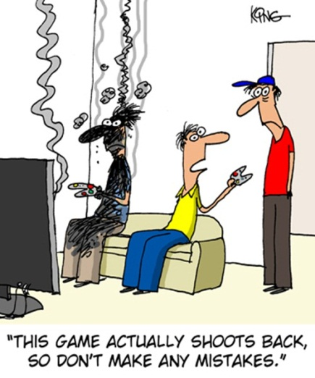**Note**: Always keep backup copies of all of your work, whether paper or electronic. Loss of material due to failure to do this is not grounds for ‘extenuating circumstances’ claims, or deadline extensions! University rules, I'm afraid.



**Some Guidance on Printing your Listings**

The first two milestones require you to produce a paper listing for marking and feedback. When producing your listings please follow the advice here and on the next page and avoid the mistakes illustrated on the subsequent page. Don't lose marks unnecessarily!

It's **NOT** advisable to print directly from **Visual Studio** as you lose much of the formatting control, although you can alter page orientation and the margins by using **File, Page Setup**…:

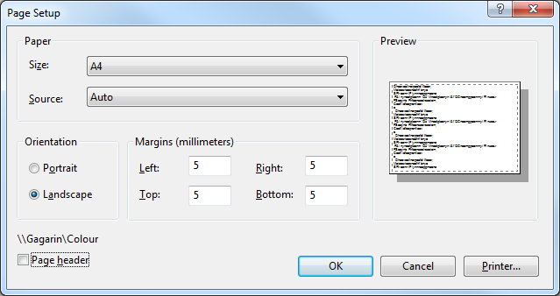

Much better is to cut and paste your code in to **Word** or somesuch, and format it properly, as shown overleaf.

* Using **landscape** orientation is always a better option, and you may have to alter the tab stop positions as Word's are different to those used in Visual Studio.
* Avoid the temptation of using spaces rather than tabs when setting out your code.
* Use **Courier** or **Consolas** as your typeface, as these are what's termed **fixed fonts** where each character has the same horizontal width (so line up neatly!). Certainly do not use **Times Roman** or **Arial** as these have different character spacings (called 'tracking' and 'kerning').
* Avoid vertical line spacing of more than 1.5 (as used here), as it just lengthens the listing for no good reason, although the occasional blank line can help separate logically distinct sections of code, such as loops (which you may also want to indent by another tab stop to emphasise them).
* Avoid the last line of a function etc, spilling onto the next page (widow lines) where it might be missed.

*This is recommended* ***whenever*** *you are asked for a program listing on paper. A sure-fire way to lose marks is to hand in poorly laid-out and hard to read (and uncommented - a cardinal programming sin) source code.*

**Note**: You do not have to produce **colour** listings.

This version has been edited down to the relevant parts only, uses landscape orientation and has moved the margins out to accommodate the comments with **no word-wrap**. Use a **fixed font** such as courier or consolas (as here) and no less than 10 point size. As the tab stops differ from Visual Studio's I've re-formatted it to look correct. Add blank lines if it helps clarify code. All on one side of paper (with longer listings consider adding page numbers). ***Beautiful***.

void encrypt_chars (int length, char EKey)

{ char temp_char; // Character temporary store

for (int i = 0; i < length; i++) // Encrypt characters one at a time

{

temp_char = OChars [i]; // Get the next char from Original Chars array

// The following comments are WH Auden's "The Night Mail" poem...

__asm { // (Well, you weren't expecting me to use actual comments, did you!?)

push eax // "This is the Night Mail crossing the border,

push ecx // Bringing the cheque and the postal order,

 // Letters for the rich, letters for the poor,

**Note**: These lines should not be deleted when doing milestones 1 and 2. It's not necessary for any reason.

movzx ecx,temp_char // The shop at the corner and the girl next door.

lea eax,EKey // Pulling up Beattock, a steady climb:

call encrypt_X // The gradient's against her, but she's on time.

mov temp_char,al // Past cotton-grass and moorland boulder

// Shovelling white steam over her shoulder,

pop ecx // Snorting noisily as she passes

pop eax // Silent miles of wind-bent grasses."

}

EChars [i] = temp_char; // Store encrypted char in the Encrypted Chars array

}

return;

__asm {

encrypt_X: push eax // "Letters of thanks, letters from banks, Letters of joy from the girl and the boy,

mov al, byte ptr[eax] // Receipted bills and invitations, To inspect new stock or visit relations,

push ecx // And applications for situations, And timid lovers' declarations

and eax, 0x7C // And gossip, gossip from all the nations, News circumstantial, news financial,

ror eax, 1 // Letters with holiday snaps to enlarge in,

ror eax, 1 // Letters with faces scrawled in the margin,

inc eax // Letters from uncles, cousins, and aunts,

mov edx, eax // Letters to Scotland from the South of France,

pop ecx // Letters of condolence to Highlands and Lowlands

pop eax // Notes from overseas to Hebrides, Written on paper of every hue,

mov byte ptr[eax], dl // The pink, the violet, the white and the blue, ...

xor edx, ecx // The chatty, the catty, the boring, adoring,

mov eax, edx // The cold and official and the heart's outpouring,

rol al, 1 // Clever, stupid, short and long, The typed and the printed and the spelt all wrong."

ret // <shortened> WH Auden 1936. See <https://www.youtube.com/watch?v=zmciuKsBOi0>

}}

This version uses Word's default portrait orientation, tab stops, and margins (which are too wide to avoid word-wrap). It looks awful. Nothing's lined up neatly. Certain to lose you marks, so please don't do this! ***We hate this!***

void encrypt_chars (int length, char EKey)

{ char temp_char; // Character temporary store

for (int i = 0; i < length; i++) // Encrypt characters one at a time

{

The dreaded **word-wrap,** avoid at all costs!

temp_char = OChars [i]; // Get the next char from Original Chars array

// The following comments are WH Auden's "The Night Mail" poem...

__asm { // (Well, you weren't expecting me to use actual comments, did you!?)

push eax // "This is the Night Mail crossing the border,

push ecx // Bringing the cheque and the postal order,

// Letters for the rich, letters for the poor,

movzx ecx,temp_char // The shop at the corner and the girl next door.

lea eax,EKey // Pulling up Beattock, a steady climb:

call encryptX // The gradient's against her, but she's on time.

mov temp_char,al // Past cotton-grass and moorland boulder

// Shovelling white steam over her shoulder,

pop ecx // Snorting noisily as she passes

pop eax // Silent miles of wind-bent grasses."

Staggered indentation looks awful

}

EChars [i] = temp_char; // Store encrypted char in the Encrypted Chars array

}

Times Roman font (not fixed width) makes it look worse

return;

// Inputs: register EAX = 32-bit address of Ekey,

// ECX = the character to be encrypted (in the low 8-bit field, CL).

// Output: register EAX = the encrypted value of the source character (in the low 8-bit field, AL).

__asm {

encryptX: push eax // "Letters of thanks, letters from banks, Letters of joy from the girl and the boy,

mov al, byte ptr[eax] // Receipted bills and invitations, To inspect new stock or visit relations,

push ecx // And applications for situations, And timid lovers' declarations

and eax, 0x7C // And gossip, gossip from all the nations, News circumstantial, news financial,

 ror eax, 1 // Letters with holiday snaps to enlarge in,

ror eax, 1 // Letters with faces scrawled in the margin,

inc eax // Letters from uncles, cousins, and aunts,

mov edx, eax // Letters to Scotland from the South of France,

pop ecx // Letters of condolence to Highlands and Lowlands

pop eax // Notes from overseas to Hebrides, Written on paper of every hue,

mov byte ptr[eax], dl // The pink, the violet, the white and the blue, ...

xor edx, ecx // The chatty, the catty, the boring, adoring,

mov eax, edx // The cold and official and the heart's outpouring,

Takes two sides of paper!

*etc, etc*

1. Those of you who like conspiracy theories may like to know that the film “*2001, A Space Odyssey*” attracted some controversy about the origin of the name for the highly impressive main computer which features so centrally in the film: ‘HAL’. Was this an early example of subtle product placement by IBM? Given that the computer finally goes ‘nuts’ in the film, perhaps not!